9. DEVELOP A HMI SCREEN FOR TRAFFIC LIGHT CONTROL SYSTEM
Aim:
To develop a one way and two way traffic light control system for the given instruction in mitshubishi PLC and HMI.
APPARATUS REQUIRED:

1. Mitsubishi FX5U [PLC Trainer kit].
2. PC.
3. Ethernet cable.

PROCEDURE:
- Load the GX Works 3 Software to the PC.
- Open the GX Works 3 Software.
- Switch ON the PLC Trainer .
- Open the New folder and draw the ladder logic program.
- Connect the PLC to PC.
- Select the correct hardware Configuration [Sl. No].
- Store the Program to PLC.
- Run the Program.
- Verify the performance of the one way and two way traffic control system in Mitsubishi kit.

ONE WAY DIRECTION:
Problem statement:
Red light glows for 30s, yellow light for 5 s, green light for 25s and this process continues. There is a start button and a stop button. Draw the ladder logic to implement the above process.

Flow diagram:
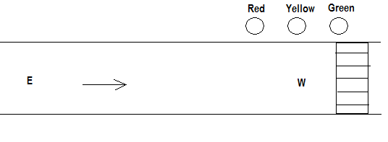

Ladder Logic:

Visualisation:

TWO WAY DIRECTION:
When Red 1 is ON for 30s, E-W traffic flows. At this instant, Yellow 2 becomes ON for 5s after which Green 2 becomes ON for 25s. After 30s, when Red 2 is ON for 30s, N-S traffic flows. At this instant, Yellow 1 becomes ON for 5s after which Green 1 becomes ON for 25s and this process continues. There is a start button and a stop button. Draw the ladder logic to implement the above process.

Flow diagram:
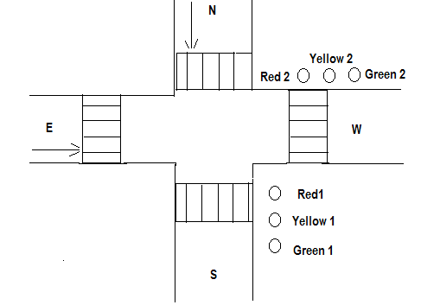
Ladder Logic:

VISUALISATION:

Result:Thus the one way and two way traffic light control was executed and verified using PLC and HMI.

